

JADAVPUR UNIVERSITY

Department of Electronics and Tele-Communication Engineering Faculty of Engineering and Technology

Digital Circuits-I Lab Assignment 7

UG-II Semester-III

NAME OF SUBMITTER : SAIKAT NASKAR

ROLL NUMBER : 302110701003

Group Members:

|  |  |  |
| --- | --- | --- |
| S.No. | Name of Student | Roll Number |
| 1. | SAIKAT NASKAR | 302110701003 |
| 2. | ANKIT DAS | 302110701004 |
| 3. | SAMUDRA SHARMA | 302110701005 |

Dated- 15.11.2021

# Lab Assignment – 7

**EXPERIMENTS ON COMPARATOR**

## OBJECTIVE:

**Performance of various experiments on comparator and analyzing the produced output.**

* 1. Verify the function table of 7485IC (4-bit comparator).
  2. Realize a 4-bit comparator using a 7485 IC.
  3. Realize a 1-bit comparator using SSI gates.
  4. Realize a 5-bit comparator using one 7485 IC and the 1-bit comparator designed in part (iii) above.
  5. Modify the 5-bit comparator circuit designed in part (iv) above to have a lesser number of gates.
  6. Cascade two 7485 ICs to realize an 8-bit comparator.

## THEORY:

**➤ Digital or Binary Comparators are made up from standard AND, NOR and NOT gates that compare the digital signals present at their input terminals and produce an output depending upon the condition of those inputs.**

**➤ There are two main types of Digital Comparator available and these are,**

**Identity Comparator - an Identity Comparator is a digital comparator that has only one output terminal for when A= B either "HIGH" A= B = 1 or "LOW" A=B=0.**

**Magnitude Comparator - a Magnitude Comparator is a digital comparator which has three output terminals, one each for equality, A=B greater than, A>B and less than A<B.**

1. Verifying function table of 7485IC:

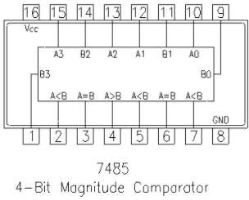

Pin2 – IA>B. Pin3 – IA=B. Pin4 – IA<B. Pin5 - fA>B. Pin3 – fA=B. Pin4 – fA<B.

A3,A2,A1,A0 and B3,B2,B1,B0 are two 4 bit numbers.

IA>B, IA=B and IA<B are the cascading inputs and fA>B,fA<B,fA=B are the outputs. Here two 4 bit no are comparing and produced an output depending on the input.

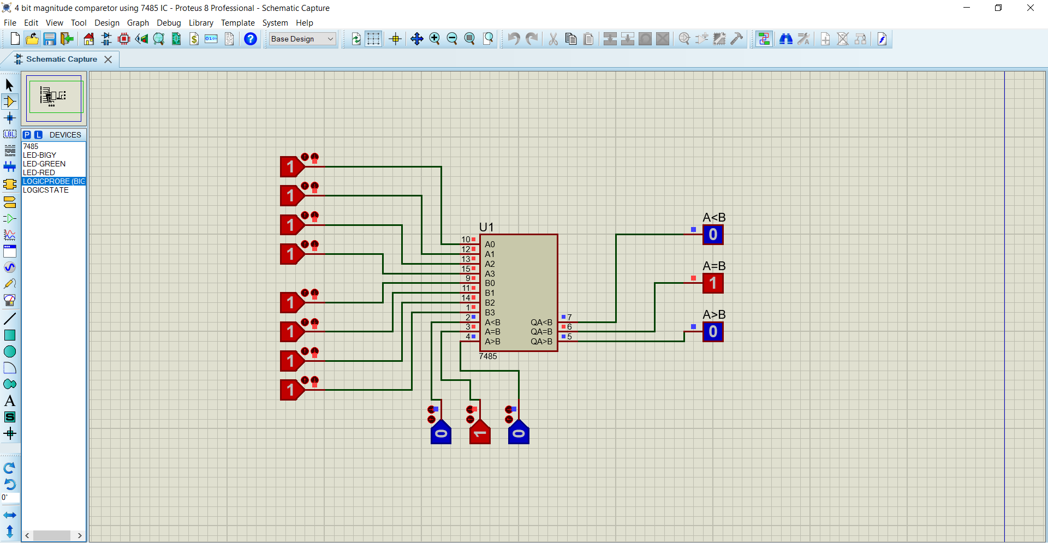

The function table has shown:

|  |  |  |  |  |  |  |  |  |  |
| --- | --- | --- | --- | --- | --- | --- | --- | --- | --- |
| COMAPRING INPUTS | | | | CASCADING INPUTS | | | OUTPUT | | |
| A3 B3 | A2 B2 | A1 B1 | A0 B0 | A>B | A=B | A<B | A<B | A=B | A>B |
| A3>B3 | X | X | X | X | X | X | 0 | 0 | 1 |
| A3<B4 | X | X | X | X | X | X | 1 | 0 | 0 |
| A3=B3 | A2>B2 | X | X | X | X | X | 0 | 0 | 1 |
| A3=B3 | A2<B2 | X | X | X | X | X | 1 | 0 | 0 |
| A3=B3 | A2=B2 | A1>B1 | X | X | X | X | 0 | 0 | 1 |
| A3=B3 | A2=B2 | A1<B1 | X | X | X | X | 1 | 0 | 0 |
| A3=B3 | A2=B2 | A1=B1 | A0>B0 | X | X | X | 0 | 0 | 1 |
| A3=B3 | A2=B2 | A1=B1 | A0<B0 | X | X | X | 1 | 0 | 0 |
| A3=B3 | A2=B2 | A1=B1 | A0=B0 | 1 | 0 | 0 | 0 | 0 | 1 |
| A3=B3 | A2=B2 | A1=B1 | A0=B0 | 0 | 0 | 1 | 1 | 0 | 0 |
| A3=B3 | A2=B2 | A1=B1 | A0=B0 | X | 1 | X | 0 | 1 | 0 |
| A3=B3 | A2=B2 | A1=B1 | A0=B0 | 1 | 0 | 1 | 0 | 0 | 0 |
| A3=B3 | A2=B2 | A1=B1 | A0=B0 | 0 | 0 | 0 | 1 | 0 | 1 |

1. Realize a 4-bit comparator using a 7485 IC.

A3,A2,A1,A0 and B3,B2,B1,B0 are two 4 bit numbers.

After comparaing the output will be :

* + 1. When A<B, fA<B will be high and the other two will be low.
    2. When A=B, fA=B will be high and the other two will be low.
    3. When A>B, fA>B will be high and the other two will be low.

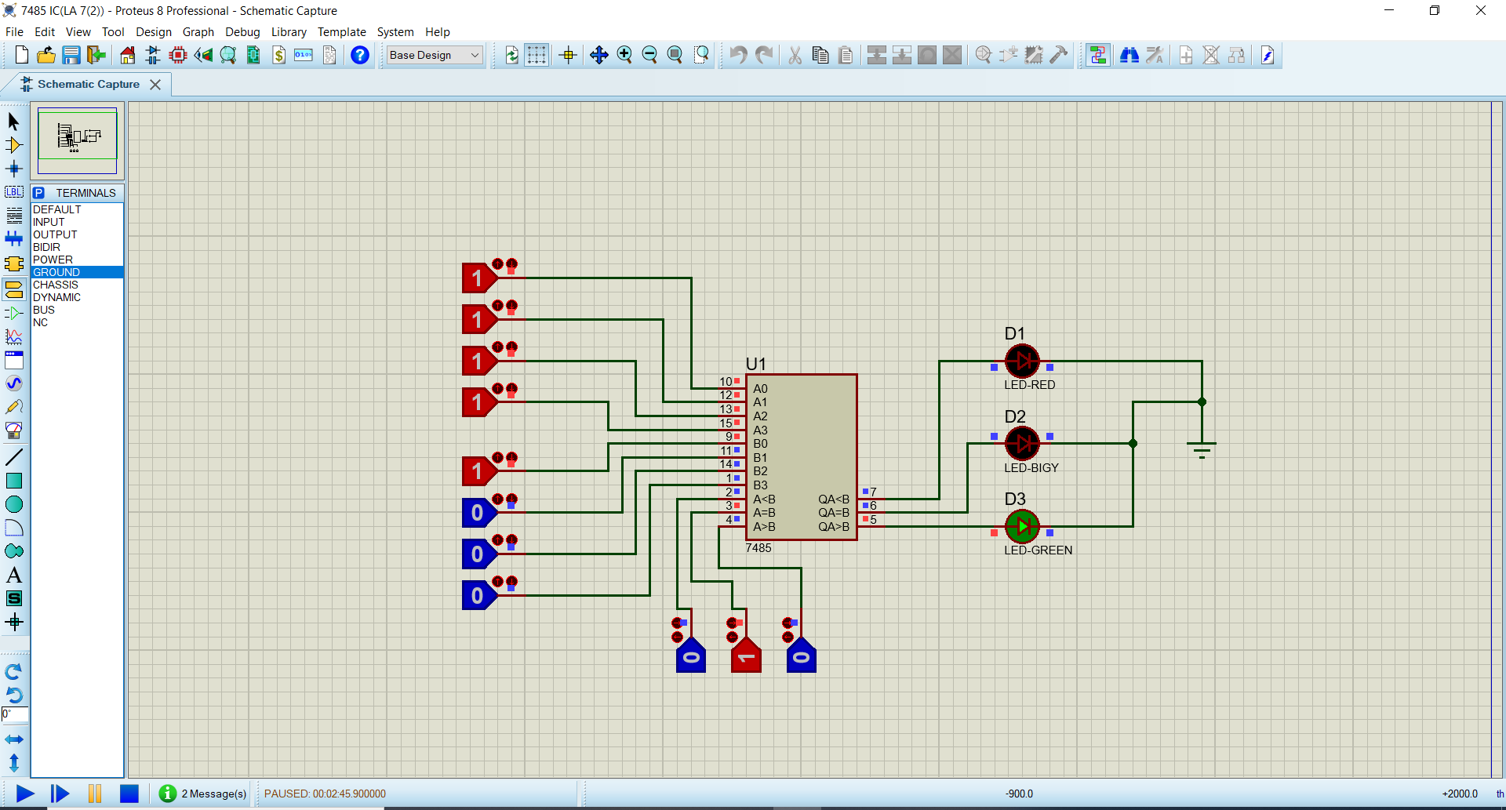

1. Realizing a 1 bit comparator using SSI Gates:

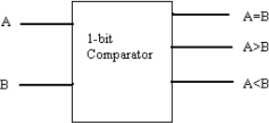

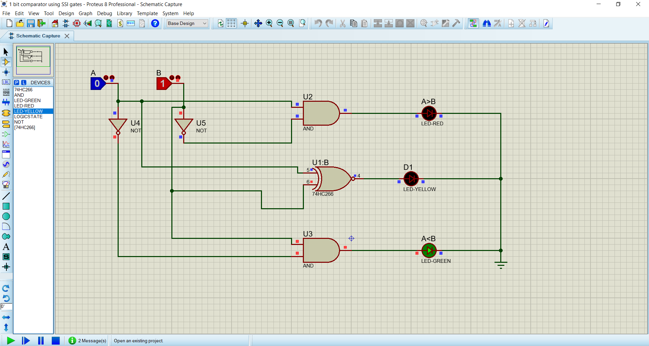

**Function table for 1 bit comparator :**

|  |  |  |  |  |
| --- | --- | --- | --- | --- |
| A0 | B0 | fA<B | fA=B | fA<B |
| 0 | 0 | 0 | 1 | 0 |
| 0 | 1 | 0 | 0 | 1 |
| 1 | 0 | 1 | 0 | 0 |
| 1 | 1 | 0 | 1 | 0 |

**_** fA<B = AB

fA=B = AB + AB

**_** fA>B = AB

1. Realizing a 5 bit comparator using one 7485IC and the 1-bit comparator designed in part (3) before:

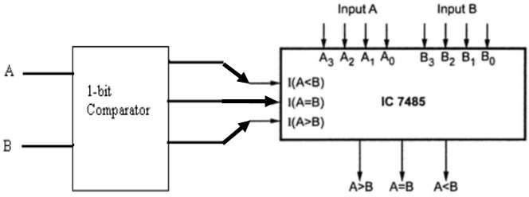

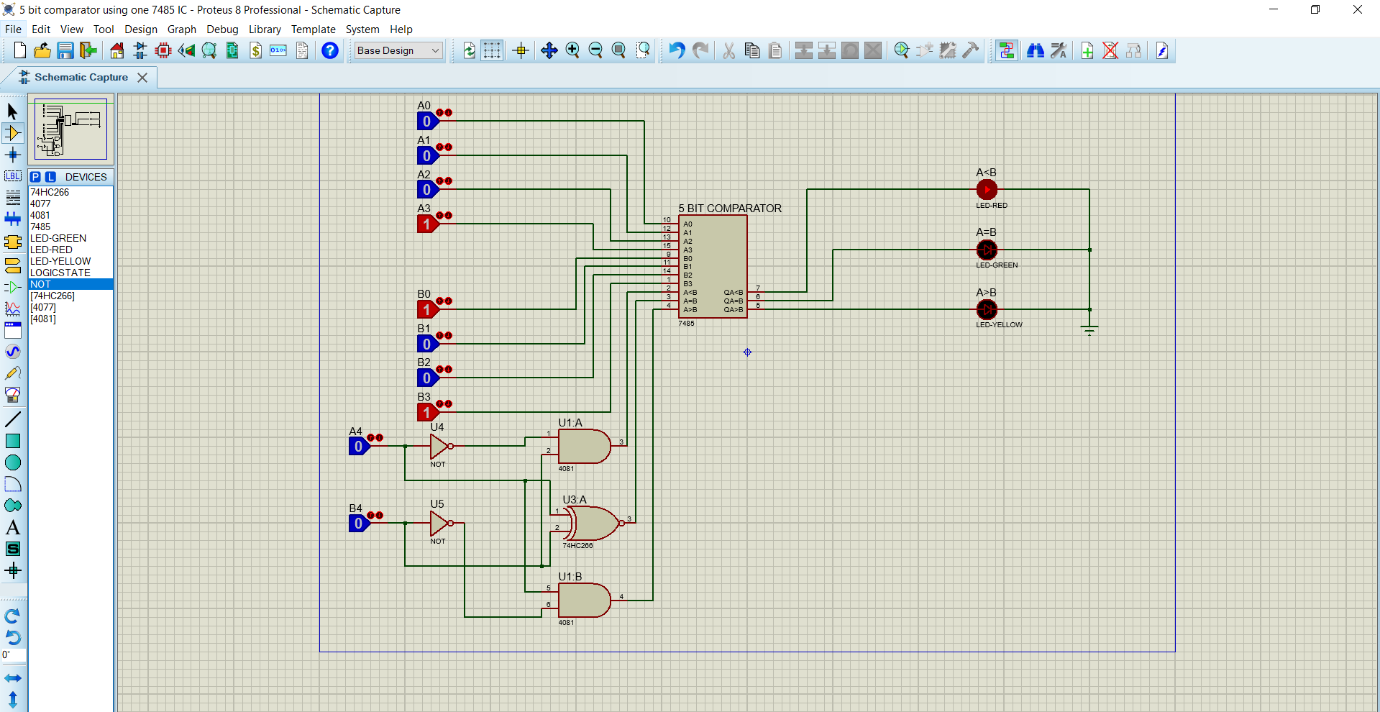

To make a 5 bit comparator the output of the 1 bit comparator can be connected to the cascading inputs of the 7485IC. The MSB is connected to the 1 bit comparator inputs and the other 4 bits of the two binary numbers are connected to the input of the 7485IC.

1. Modify the 5 bit comparator made in part (4) with less no. of gates:

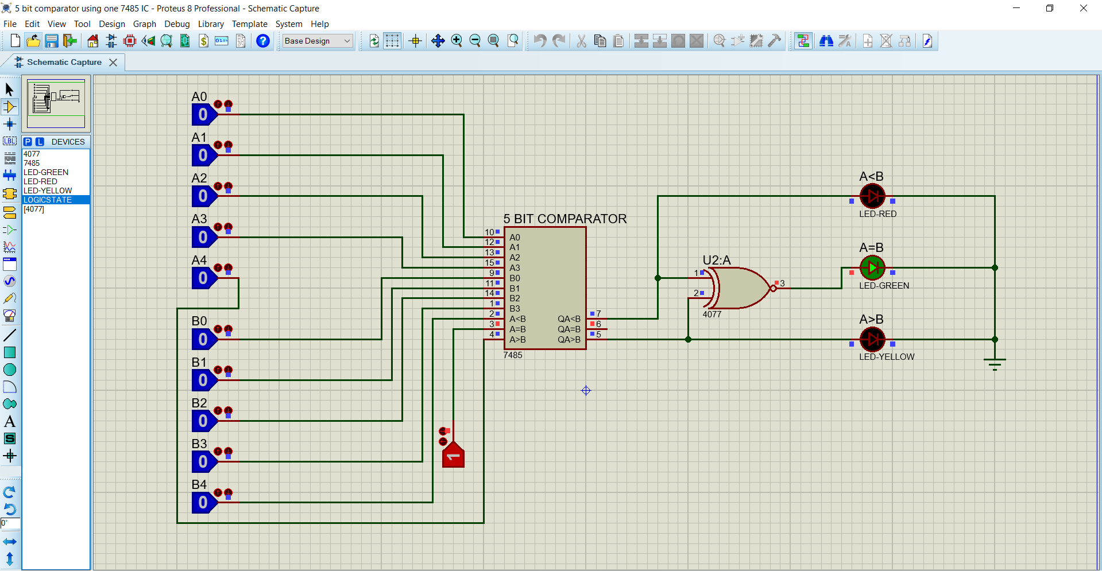

A 5-bit comparator can be modified by adding 1 XNOR gate with 7485 IC instead of the 1 bit comparator. The two MSB are connected to the two cascading inputs IA>B and IA<B of the 7485IC. The result of the two output A<B,A>B are being connected to an ex-nor gate and the output of ex-nor gate is A=B. Thus, it has been modified using lesser no. of gates.

1. Cascading two 7485ICs to realize one 8-bit comparator:

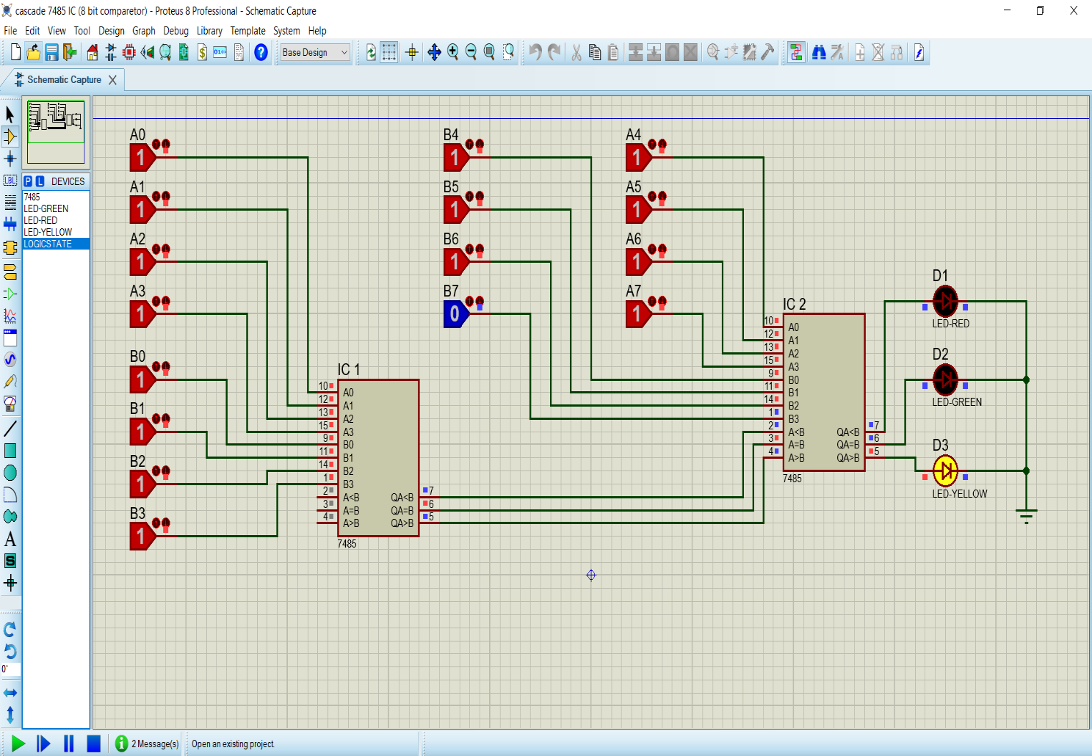

By cascading two 7485 ICs a 8 bit comparator can be realized. The output of the LSB IC’s are connected to the respective cascading inputs of the MSB IC. The **IA>B and IA<B** cascading LSB IC’s can be connected to either high or low. The **IA>B** cascading input of the LSB IC should be connected to high input. The output of the MSB IC will determine the actual output.

## CONCLUSION:

A comparator is an electronic combinational circuit which is used to compare to input signals and produces an output of which signal is greater or if they are equal. 7485 IC is a 4 bit comparator but it also have some added advantages. The cascading inputs play very vital role when both the signals are equal as then they define the output. Also, using this cascading inputs, we can make higher order comparator. In digital electronics field, it’s a huge application of 7485 IC.